Statement
We are looking to develop a clean and user-friendly website that whilst providing high quality promotion and informative content is an efficient and effective process for creating sales.

Requirements provided in bullet point form
- Site must be incorporated with ecommerce options
- Site must have an account area for users for them to access their bookings/memberships -
- Site landing page must provide an excellent user experience with easy navigation to desired areas - Tahir Group - Design Gallery
- Main services must have a dedicated promotion page (the main service can be seen in the service offers document) - As above
- There must be a space for one off specialist events for booking. - Sushi Workshop London - Design Gallery
- A policy area - As standard
- A contact us area – As standard
- A clean and user-friendly check out process – including T+C agreement requirements and opportunity to grow database - Ticketmaster example
Image 1 shows
Checkout with add to order option
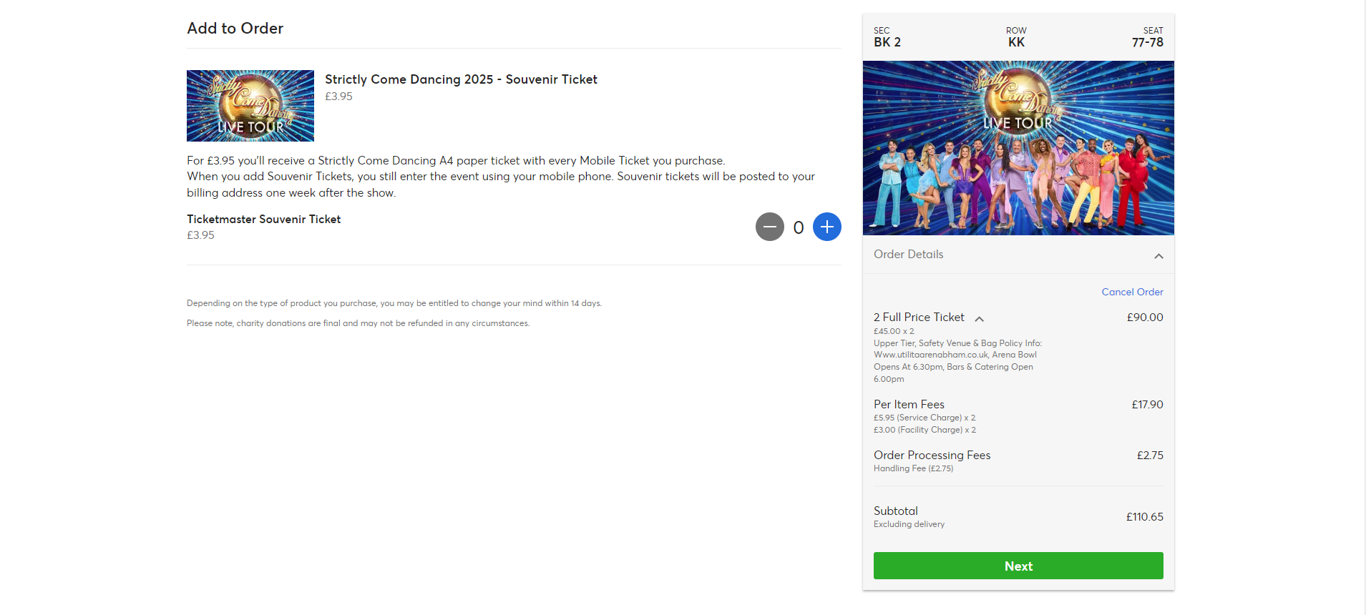
Image 2 shows option to opt into database and confirmation that when buying you accept terms of service
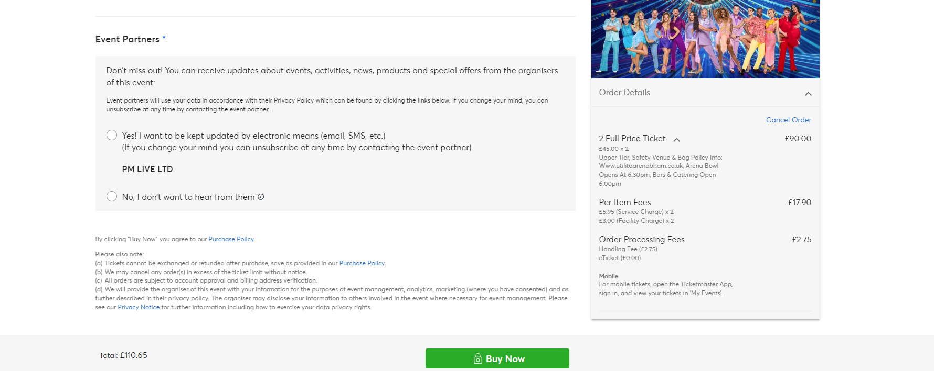
- Google analytics and data tracking embedded for marketing purposes - we will provide codes etc
- An area for latest news/blog content for SEO reasons
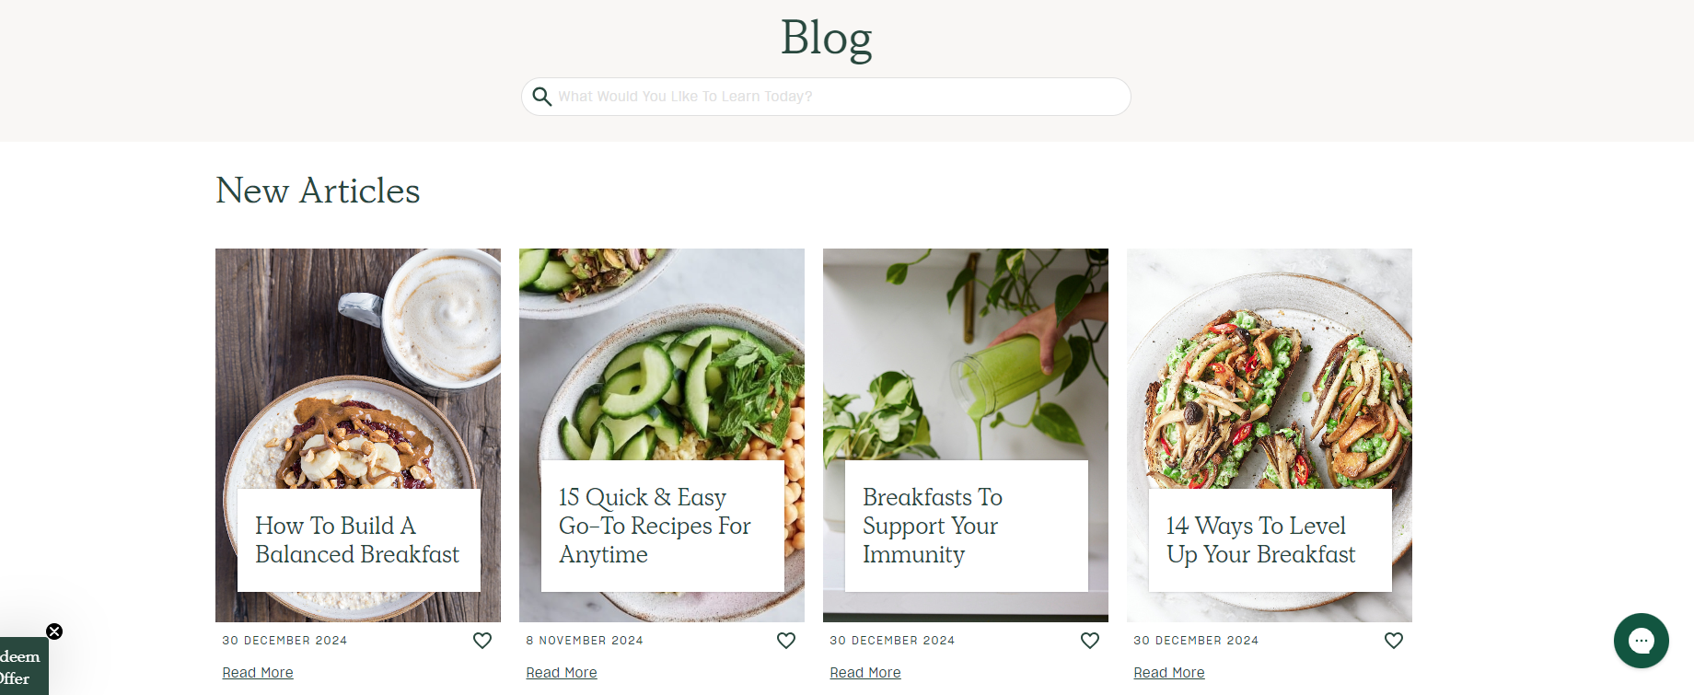
- In the back end a space where registers and sign ups can be easily viewed and extracted for compliance and company organisation reasons
- Any extras/you may also be interested in option when the basket is open. (these would mostly be upcoming one off events) - see ticketmaster example above
- During selection of pathway sessions a customer will have to select sport/arts or tutoring and then the selected discipline – lists will be provided - this is just a dropdown list
- An opportunity to select available recurring session time such as attached link also needed for pathways – week availability should be shown for selection -
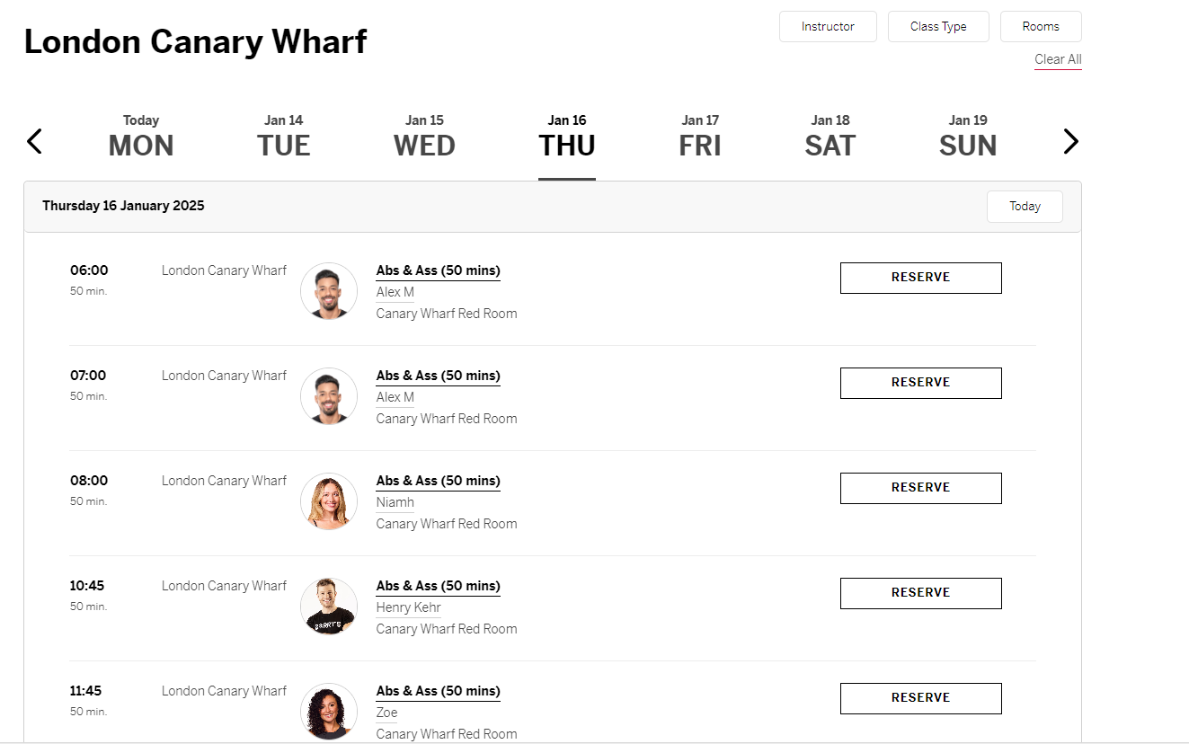

More detailed notes for consideration
- For the membership style sign out options something similar to the attached would be initial preference - https://ecom.docusign.com/en-GB/plans-and-pricing/esignature?_gl=1*5yr3qq*_gcl_au*MTYzMzcyMjYxNy4xNzMxMDY4MTgx
- For Holiday club/sports club bookings requirement is Mutiple calendar selection and quantity option for e.g. if I want to book 2 children into the whole week, I should be able to select this in the calendar view for automatic feedthrough to my basket. - WP Booking Calendar – WordPress plugin | WordPress.org - multiple dates selectable

- In some circumstances such as when a customer selects a platinum pathway subscription they also recieve the unlimited group sessions, how is best for this to work on the site (is it to be auto added to their basket) they would also receive automatic savings on sports camps could this trigger when they are locked in or would it have to be a code?
- Can the invoice option only appear when the school/orgnisation option is in the basket?

